School of Computer Applications
Department of Master of Computer Applications
SEM Examination Summer – 2026
Semester – II
Class Test – II Practical Exam
Sub Code: 240110203 | Division: E | Total Marks: 50 (including VIVA)
Sub Name: Object Oriented Programming with JAVA (OOPJ)
SET-2
A | Vector + BufferedInputStream / BufferedOutputStream [20 Marks]  Write a Java program to store Student data using Vector and perform buffered binary file copy.  The program should perform the following:  • Accept 5 student names from the user and store them in a Vector<String>.  • Use an Iterator to write all names into a source file 'source.txt' using PrintWriter.  • Copy the contents of 'source.txt' to 'backup.txt' using BufferedInputStream and BufferedOutputStream (byte-by-byte binary copy).  • After copy, read 'backup.txt' using BufferedReader and display its content.  • Display file size using File.length() before and after copy to confirm success.  • Handle IOException properly. | 20
B | Swing – Color Theme Changer [20 Marks]  Design a Color Theme Changer application using Java Swing:  • JLabel at the top displaying 'Select a Theme'.  • JComboBox with 5 color themes: Default (White), Ocean Blue, Sunset Orange, Forest Green, Lavender.  • A large JPanel (center area) that changes its background color based on the selected theme.  • JButton — 'Apply Theme' to apply the selected color.  • JButton — 'Reset' to restore the panel to white background.  • JLabel at the bottom displaying the currently applied theme name.  • On selecting from JComboBox and clicking Apply → update JPanel background and bottom JLabel.  • Use BorderLayout for overall arrangement.  Expected Output: 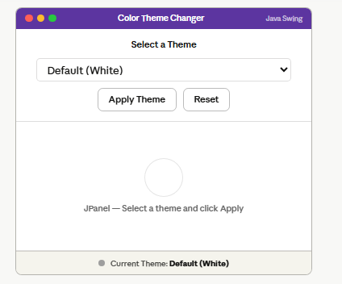 | 20
 | Viva | 10

